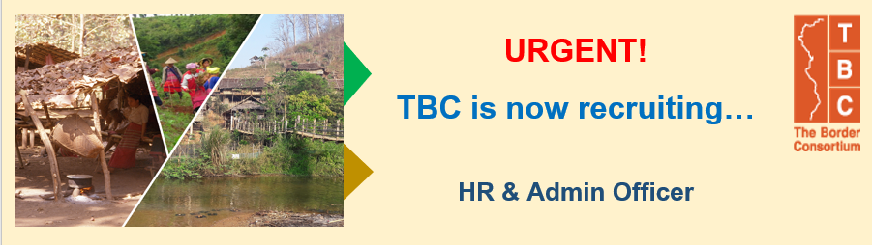

The Border Consortium (TBC) works with conflict affected communities in SE Burma/Myanmar and 9 refugee camps in Thailand building preparedness for return and reintegration of displaced people. Through local partners and community led processes, TBC supports access to Food, shelter, capacity building for community management, and rehabilitation of conflicted affected communities. Now we are URGENTLY seeking HR & Admin Officer to join the team.
Job Purpose:
The HR & Administrative Officer position provides HR/administrative support to the Bangkok office in HR/ Administration Unit and coordinates with Field Administrator based in different field sites; Tak, Mae Hong Son, Chiang Mai Office and Offices in Myanmar as well.
This position will work closely with HR and Admin Team to support and deliver services on different facets of HR & Admin practices such as HRMS, payroll, training, recruitment, visa and occasionally on general administration works as assigned
Reporting Line:
This job reports to HR & Admin Specialist.
Type of Employment/ Location:
Full time-open ended contract/ Bangkok
Job Responsibilities:
Core Responsibilities & Duties
- Assist database processing including database entry, database updating, database compilation and help to communicate information from HR & Admin Team to TBC staff.
- Provide insurance coverage of TBC assets (application, renewal).
- Assist in budget preparation for meetings, trainings, and workshops.
- Help monitoring the expenditure of each meeting and workshop for budget control.
- Coordinate with IT outsourcing company for users’ support.
- Provide general support to colleagues as per request.
- Support HR & Admin team during an absence of a team.
HR:
- Develop and maintain HR master database.
- Generate and maintain HR related reports and documents for the purpose of HR management and decision making such as performance management system, leave record, medical claim record, staff demographics, and etc.
- Maintain a complete record of all human resources and filing in the organization.
- Ensure that HR documents and files are handled with proper confidentiality and tracking
- Process accurate and timely monthly payroll while maintaining strict confidentiality at all times.
- Assist in recruitment process for job posting, initial screening, communicating with candidates during the selection process up to final selection, making an appointment with the candidates, and prepare interview documents.
- Prepare the renewal of international staff contract.
- Ensure all compensation and benefits are in place according to the TBC policy; and that all employees access information and benefits as they are entitled.
- Update information with insurance company for new hired or resigned staff and to ensure the accuracy of the contract with insurance companies upon renewal.
- Support employee relation activities and be able to seek training courses that match with TBC training roadmap.
- Engage TBC employee through effective communication approach and channels so that staff will understand TBC’s direction and policy.

Others:
- Support visa and work permit application process for international staff and their dependences.
- Coordinate with Ministry of Interior and TBC’s field office to support all camp pass process and permission letters per request.
- Provide other forms of support as required and/or requested by HR & Admin Specialist.
Job Requirements:
- Bachelor in related field
- 2-4 years experiences in HR & Admin work
- Good people and inter-personnel skills
- Good organization and management skills
- Possess customer service mind
- Problem solving skills
- Attention to details
- Team player
- Good command of Thai & English both in writing and speaking
- Excellent computer literacy in MS office esp. MS Xcel and PowerPoint
- Excellent with communications skill with positive thinking is a must
- Have high level of flexibility and adaptability
- Like to explore areas beyond comfort zone
- Demonstrated experience and a successful track record working with minimal supervision and with flexibility
- Strong communications – Written and Oral English

Application Closing Date : 18th May 2021
Expected Start Date : June 2021

How to Apply:
- Please submit a current CV/resume including 2 references and a cover letter explaining why you are suitable for this post to hr@theborderconsortium.org
- Only short-listed candidates will be contacted.
*TBC is an equal opportunity employer that values diversity at all levels.*
(Minorities/Females/People with Disabilities)

