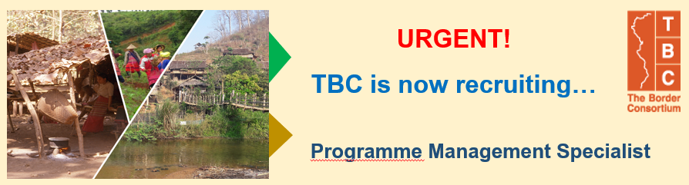

The Border Consortium (TBC) works with conflict affected communities in SE Burma/Myanmar and 9 refugee camps in Thailand building preparedness for return and reintegration of displaced people. Through local partners and community led processes, TBC supports access to Food, shelter, capacity building for community management, and rehabilitation of conflicted affected communities. Now we are URGENTLY seeking Programme Management Specialist to join the team.

Job Purpose:
This position will work with TBC’s Senior Management Team (SMT) to provide oversight of partnership with donors, ensure programme implementation meets donor requirements and identify and secure funding and resource opportunities. This position will also support organisational communications needs.
Reporting Line:
This job reports to Executive Director.
Type of Employment/ Location:
One-year-contract with possibility of renewal/ Bangkok-Thailand
Job Responsibilities:
Core Responsibilities & Duties
- Monitor and coordinate all programme management and proposal development efforts in Thailand and Myanmar.
  - Lead the Programme Development and Quality Assurance (PDQA) unit in supporting programme/grants management including donor compliance, reporting, and regular communications with partners and stakeholders.
  - Assists with programme development proposals. Regular monitoring and and reporting on the status of donor funded activities.
  - Supports SMT in developing a strategic plan with benchmarks.
  - Ensure programme development is aligned with TBC’s strategy and substantiated with a Theory of Change, Project
  - Management Plan (or monitoring, evaluation and learning plan) and/or log frame.
- Develop proposals in consultation with Senior Management Team and other specialists in line with TBC’s strategic directions.
- Work with the Senior Management Team to manage proposal cycle, ensuring TBC and donor standards and requirements are met.
- Build relationships with representatives of current and potential donors (traditional and non-traditional) and strategic partners.
- Continuously assess and develop M&E (mentoring and evaluation) systems and tools to ensure that the methodologies used and the information gathered are suitable to programme and donor needs.
- Communicate regularly with program and field staff as well as other departments on ongoing and planned program development efforts, specific support needs and field staff capacity building requirements.
- Attend meetings, conferences, and workshops that are related to programme development and donor relationship building and communication.
- Provide supervision and support to Communication & Reports Manager to ensure appropriate communication reporting of programmes, grants and contracts to related particies.
- Develop in conjunction with Senior Management Team, grant administration policies and procedures in accordance with donors’ regulations.
- Monitor the progress of each project and assist with the identification of issues which may affect the quality of programme performance and consequent program adjustments.
- Provide support to Communication & Reports Manager in developing TBC’s communication strategy and messages that resonate with organisational strategic direction and goals to ensure consistency and clarity for donors, TBC’s employees and other related stakeholders towards TBC’s programme operation and stakeholder management.
- Undertake all other duties and projects as may be assigned from time to time.
Job Requirements:
- A Bachelor or master’s degree in relevant discipline
- A minimum of 5 years of experiences
- 2 – 4 years managing partnerships with institutional donors including one or more of the following; USG/PRM, DFID, DFAT, GAC (CIDA), EU, UN Extensive knowledge of proposal and donor funding requirements and application of M&E and learning methods
- Knowledge of Theory of Change
- Knowledge in finance
- Strong critical thinking and problem solving skill
- Ability to perform under time pressure, be flexible, work independently and manage multiple tasks
- Work effectively as a leader and team member in fast-paced multi-cultural environment
- Willingness and capacity to hold collaborators accountable for deliverables
- Strong written and oral communication skills with an enthusiasm for writing
- High fluency in English is imperative– Myanmar/Thai language a bonus

Application Closing Date : 18th May 2021
Expected Start Date : Mid-June 2021
How to Apply:
Please submit a current CV/resume including 2 references and a cover letter explaining why you are suitable for this post to hr@theborderconsortium.org
- Only short-listed candidates will be contacted.
*TBC is an equal opportunity employer that values diversity at all levels.*
(Minorities/Females/People with Disabilities)

